**Step 1:- First Create 2:1 Mux :-**

----------------------------------------------------------------------------------

-- Company:

-- Engineer:

--

-- Create Date: 12:24:59 09/25/2017

-- Design Name:

-- Module Name: MUX2TO1 - Behavioral

-- Project Name:

-- Target Devices:

-- Tool versions:

-- Description:

--

-- Dependencies:

--

-- Revision:

-- Revision 0.01 - File Created

-- Additional Comments:

--

----------------------------------------------------------------------------------

library IEEE;

use IEEE.STD_LOGIC_1164.ALL;

use IEEE.STD_LOGIC_ARITH.ALL;

use IEEE.STD_LOGIC_UNSIGNED.ALL;

---- Uncomment the following library declaration if instantiating

---- any Xilinx primitives in this code.

--library UNISIM;

--use UNISIM.VComponents.all;

entity MUX2TO1 is

Port ( A : in STD_LOGIC;

B : in STD_LOGIC;

S : in STD_LOGIC;

E : in STD_LOGIC;

Y : out STD_LOGIC);

end MUX2TO1;

architecture Behavioral of MUX2TO1 is

begin

Y<= NOT E and ( (( NOT S AND A) OR (B AND S) ));

end Behavioral;

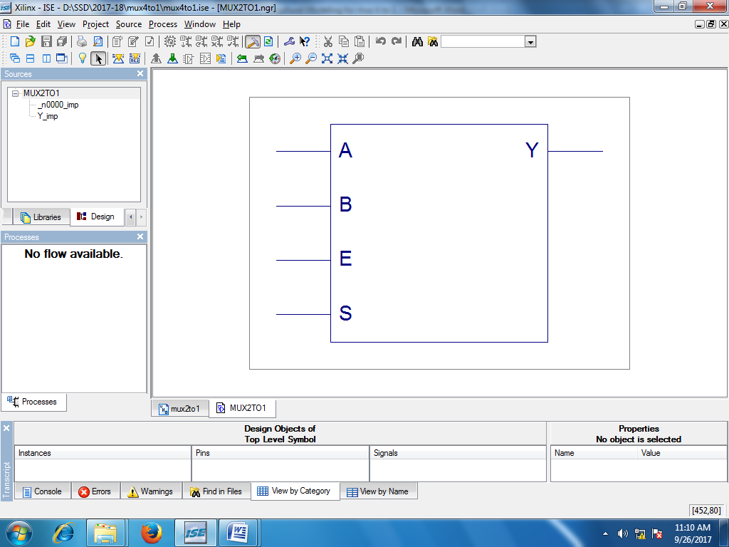

**Step 2:- Create 4:1 using 3 2:1 Muxes**

----------------------------------------------------------------------------------

-- Company:

-- Engineer:

--

-- Create Date: 10:57:47 09/26/2017

-- Design Name:

-- Module Name: m4to1 - Behavioral

-- Project Name:

-- Target Devices:

-- Tool versions:

-- Description:

--

-- Dependencies:

--

-- Revision:

-- Revision 0.01 - File Created

-- Additional Comments:

--

----------------------------------------------------------------------------------

library IEEE;

use IEEE.STD_LOGIC_1164.ALL;

use IEEE.STD_LOGIC_ARITH.ALL;

use IEEE.STD_LOGIC_UNSIGNED.ALL;

---- Uncomment the following library declaration if instantiating

---- any Xilinx primitives in this code.

--library UNISIM;

--use UNISIM.VComponents.all;

entity m4to1 is

Port ( a : in STD_LOGIC;

b : in STD_LOGIC;

c : in STD_LOGIC;

d : in STD_LOGIC;

s0 : in STD_LOGIC;

s1 : in STD_LOGIC;

E: in STD_LOGIC;

y : out STD_LOGIC);

end m4to1;

architecture Behavioral of m4to1 is

component MUX2TO1 is

Port ( A : in STD_LOGIC;

B : in STD_LOGIC;

S : in STD_LOGIC;

E: in STD_LOGIC;

Y : out STD_LOGIC);

end component;

signal y1,y2: std_logic;

begin

mux1 : mux2to1 port map (a,b,s0,E,y1);

mux2 : mux2to1 port map (c,d, s0,not E,y2);

mux3 : mux2to1 port map (y1,y2,s1,E,y);

end Behavioral;

* 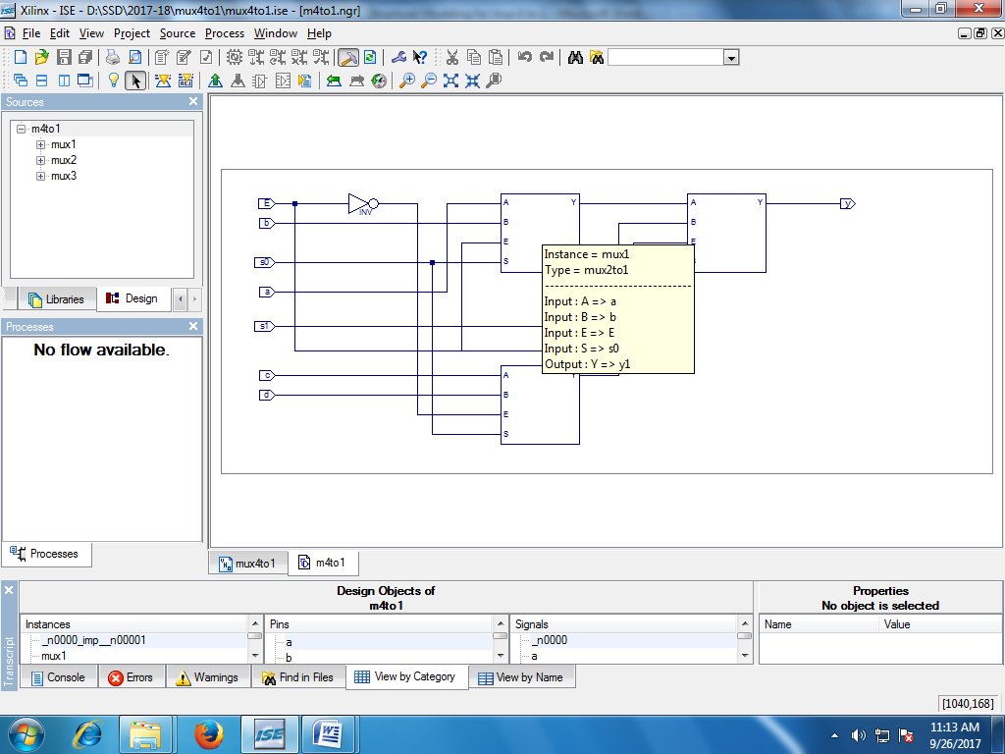 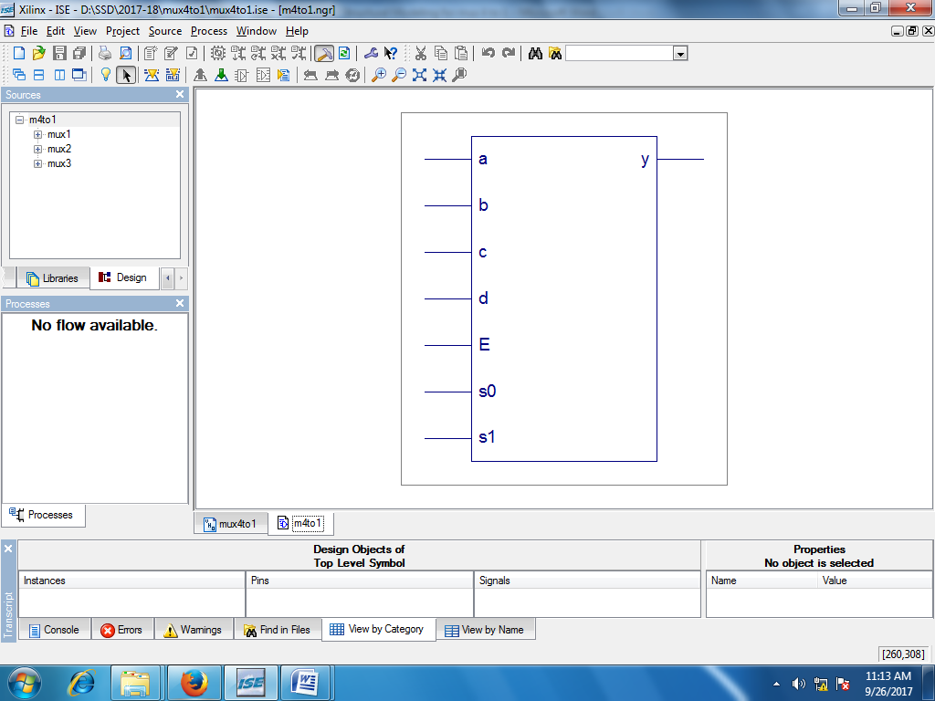

Output:-

